VIRTUAL PRACTICAL WORK IN HPLC

Introduction
Optimizing a separation by High Performance Liquid Chromatography (HPLC) consists in finding the best experimental conditions for a given separation, to ensure sufficient resolution (Rs) within the shortest possible analysis time.
The theoretical understanding of the retention mechanisms in liquid chromatography, particularly the reverse phase liquid chromatography mode, is now established and modeling software (DryLab®, ACD-Lab® or Osiris®) is available to help developing separations. They are part often used in industries and are allowed by the authorities. Other software, less sophisticated but free, are also available, mainly for the educational purpose, such as the one that will be used in this virtual experiment.

The aim of this work is to study the impact of the different chromatographic parameters on the retention of several compounds and the separation quality in HPLC. Several exercises are thus proposed to learn HPLC in reversed phase mode (RPLC).

Theoretical background
The chromatographic mode chosen for this virtual practical work is reverse-phase liquid chromatography (RPLC). Its separation mechanism is based on the partitioning of a solute (analyte) between an apolar stationary phase and a polar mobile phase.
The stationary phase is a silica gel bonded with alkyl chains containing four (C₄ ), eight (C₈ ) or eighteen carbon atoms (C₁₈ ) using the reaction below.

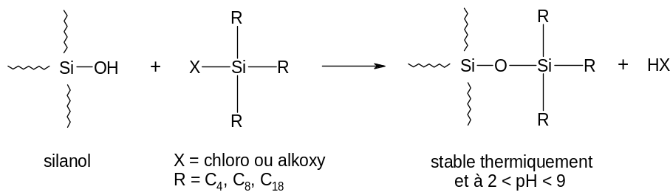

a) 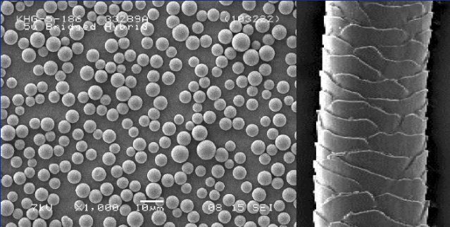 b)
Si
Si
Si
Si
Si
Si
Si
Si
Si
Si
O
O
O
O
O
O
Si
Si
Si
Si
Si
Si
O
O
O
O
O
O
Si
Si
Si
Si
Si
Si
Si
Si
Si
Si
Si
Si
Si

Figure 1 : a) 5 μm silica particles and hair shown on the same scale (www. waters.com), b) Alkyl chains bonded onto silica particles interacting with the hydrophobic parts of a molecule.

The mobile phase in RPLC is typically an hydro-organic mixture (water/methanol or water/acetonitrile), often containing a buffer to control pH.
The chemical interactions are essentially hydrophobic: the partition of the analyte between the stationary phase and the mobile phase make it possible to predict the elution order of a series of compounds. Thus, in RPLC, the retention of an analyte :
- Decreases with its polarity (the more polar compound is eluted first)
- Increases with the polarity of the mobile phase (opposite to TLC on silica plate which is carried out in normal phase mode).

Studying the retention of parabens
Open this address on the internet browser and download the software (version with macros) in the form of an Excel file: https://ispso.unige.ch/labs/fanal/practical_hplc_simulator
The software is an Excel file containing macros. You must therefore activate the possibility of using macros in Excel when starting the software.

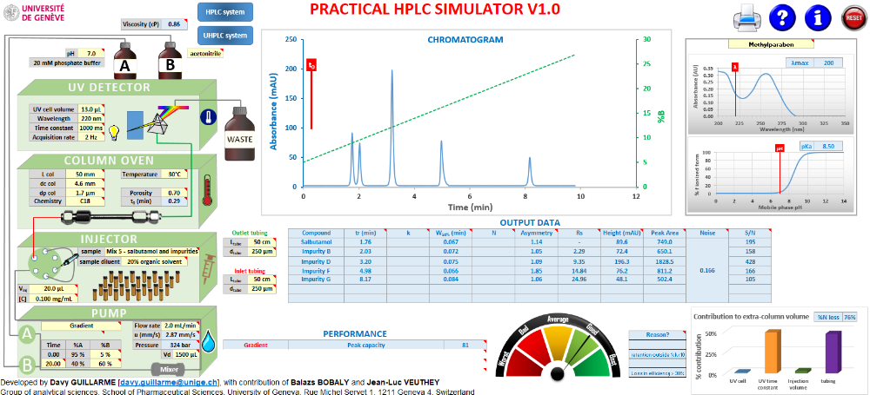

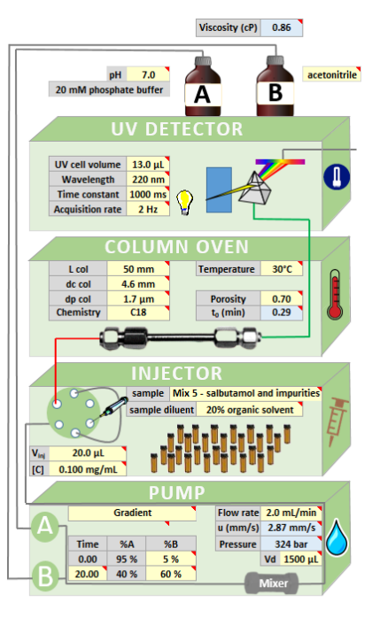

In the main window, the chromatographic system is located on the left (in green) and includes the modules that are usually found on an HPLC system (pump, injector, column oven, detector, chromatographic column and bottles containing mobile phases). In this left part, we find all the parameters and variables having an effect on the separation. The organization is made in different modules from bottom to top: 1) pump, 2) injector, 3) column oven and chromatographic column, 4) UV detector, 5) mobile phase bottles.

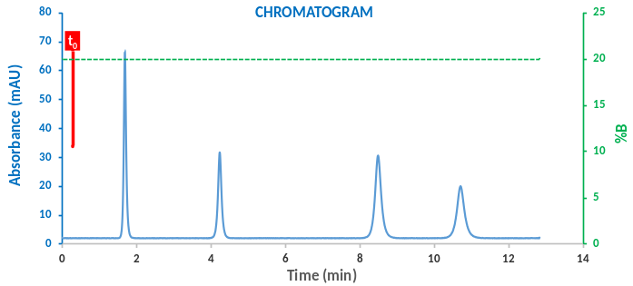
The chromatogram simulated under the conditions used is displayed in the central part of the software. Below, there is a blue table with the list of compounds present on the chromatogram, their retention time (t_{r}), retention factor (k), width of the peaks at half-height (W_{50%}), efficiency (N), asymmetry, resolution (Rs), peak height, peak area, background noise and signal to noise ratio (S/N).
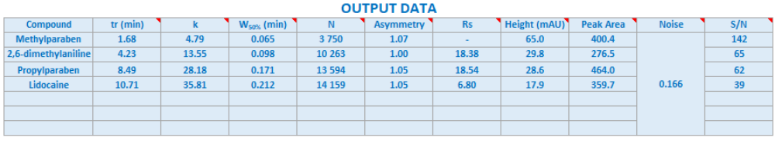

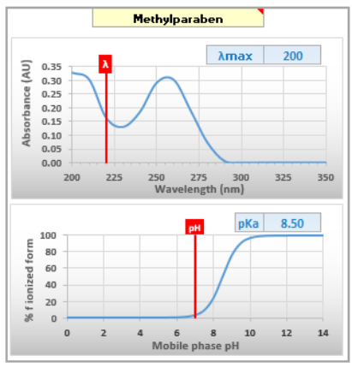

On the right side of the software, there are two grey graphics. Here, it is possible to select a compound contained in the mixture to be analyzed, in order to view its UV spectrum, as well as ionization profile (charge state as a function of pK_{a}).

Finally, the software has a red button "reset"  in the upper right corner, which resets the original values of the program. Not all features of this software will be used during this virtual practical work.

2.1. Elution order of parabens

Start by clicking on the reset button , so that all the values ​​of the software are reset to default values.
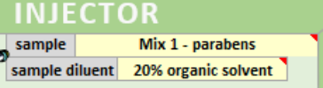
Select the mixture to be analyzed on the "injector". Choose "Mix 1 - parabens". This mixture contains uracil as well as 4 parabens. Uracil is used in HPLC as a dead time marker (compound not retained in HPLC), and will therefore always be eluted first (be careful, uracil is not visible on the chromatogram when the reference values of the software are used, it does not absorb at 220 nm).
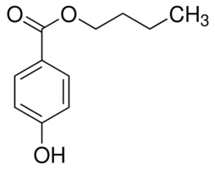
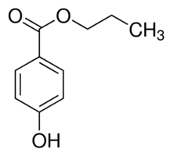
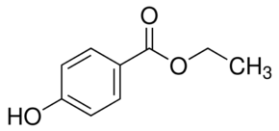
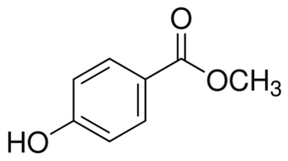

Methylparaben Ethyparaben Propylparaben Butylparaben

Parabens are widely used as preservatives by the pharmaceutical and cosmetic industries. These compounds are chosen mainly for their bactericidal and fungicidal properties. They can be found in shampoos, commercial moisturizers, shaving foams, lubricants, parenteral pharmaceutical formulations, makeup and toothpastes. They are also used as food additives. Furthermore, parabens are often used as test compounds in RPLC to measure column efficiency and hydrophobic selectivity.

What order of elution do you expect for the 4 parabens, keeping in mind that the stationary phase is bonded with C18 groups ? Justify your answer.

2.2. Study the impact of mobile phase composition on retention

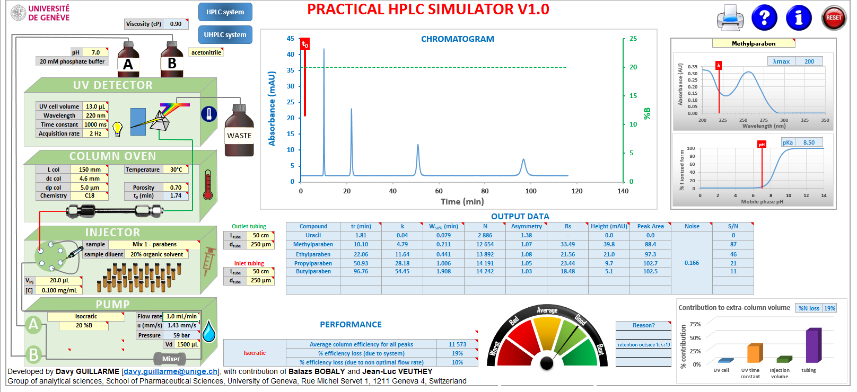
The working temperature for this exercise is set at 40°C. it should be set it in the software on the "column oven" part before starting the exercise.

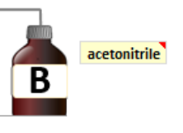
Adjust the mobile phase composition to 30 % acetonitrile in isocratic elution mode. The isocratic elution mode and the %ACN must be selected on the “pump” part, while the nature of the organic solvent used (acetonitrile) must be set on the “mobile phase bottles” part.
Create a table with retention times and retention factors of the 4 parabens. These values ​​are available in the blue table below the chromatogram.
Then, change the mobile phase composition to 20 % and then 40 % acetonitrile and complete the table you have created. What can you conclude ?

By varying the proportion of acetonitrile freely between these values, which percentage would you recommend to have a baseline separation (Rs ≥ 1.5), while being as fast as possible ?

As a reminder, the retention factor is calculated very simply from formula (1):
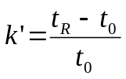 (1)
Here, t_{R} is the retention time of the compound and t ₀ is the column dead time (measured experimentally with uracil or calculated from the column dimensions and the flow rate).

The advantage of using k ' rather than retention time is that it is independent of the dimensions of the column used.
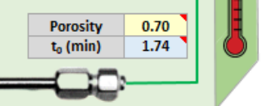
The dead time of the column is also estimated by the software (calculation based on the dimensions, the porosity of the stationary phase as well as the mobile phase flow rate). It can be found in the "column oven" module on the left side of the screen.
Below are the log P values ​​of the 4 parabens studied.

 | Methylparaben | Ethyparaben | Propylparaben | Butylparaben
Log P | 1.8 | 2.4 | 2.9 | 3.4

Plot the graph log (k') = f (log P). Use k' values ​​at 30 % acetonitrile. Describe briefly the shape of the curve and give your conclusion.

In RPLC, the logarithm of the isocratic retention factor obeys a linear relationship as a function of the composition of the mobile phase (denoted φ). This fundamental relationship is called Linear Solvent Strength theory (LSS).
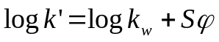 (2)
where k_{W} is the extrapolated value of the isocratic retention factor of the compound in pure water (y-intercept), and S is the solvent sensitivity factor (slope) of the compound.
φ is used here in its decimal value. For example, 30 % solvent B corresponds to φ = 0, 30.

Plot the graphs of k 'as a function of φ for each paraben.
Then, check the linear relation of equation (2) by plotting the graphs of the logarithms of the retention factor (log k') as a function of φ. Give your conclusion.

2.3. Selectivity calculations and resolution
To separate 2 compounds, it is first necessary that their respective retention factors are different (i.e. selectivity > 1), otherwise they would be eluted together (co-elution) and therefore without effective separation.

The selectivity (α) is the ratio of the retention factors between two compounds eluted successively.
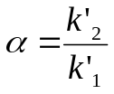 (3)
where k'₂ is the retention factor of the peak eluted later and k'₁ that of the peak eluted first.
However, the most important parameter is the resolution (R_{S} ) which also takes into account the width of the peaks, in addition to the distance between two successive peaks. The resolution is therefore a quantitative measure of the ability to differentiate the elution of 2 peaks during a chromatographic separation. It is defined by the ratio of the difference in the retention times of the 2 peaks (t_{R1} and t_{R2} ) divided by the sum of their widths at the base (w₁ and w₂ ) .
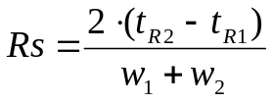 (4)
A total co-elution corresponds to a resolution of 0 and a selectivity of 1.

In most cases (Gaussian peak), a resolution greater than 1.5 (Rs ≥ 1.5) is required, to achieve complete separation, known as “baseline”.

Calculate the selectivity and note the resolution given in the results table (blue table below) between the peaks of the various parabens at 35°C (adjust the temperature in the software on the “column oven” part), and 25% acetonitrile.
What is the critical pair for the separation ?

Studying efficiency in HPLC
The dispersion (width) of the chromatographic peak is generally characterized by the height equivalent to a theoretical plate (denoted H or HETP) and the number of theoretical plates (N). These values ​​represent the separation efficiency.

The number of theoretical plates and the plate height (column length necessary to obtain one theoretical plate) are simply related by the length of the column (L) :
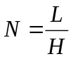 (5)
Van Deemter proposed an equation to describe the performance of a column according to the linear velocity of the mobile phase (u), which is directly related to the flow rate.
For the sake of simplicity, we will use the flow rate values (rather than linear velocity) in this part of the work.
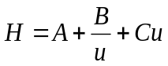 (6)
where A, B and C are constants determined by the amplitude of the dispersion (width) of the elution band.
Equation (6) describes a mathematical function which exhibits an optimum. At this optimum mobile phase linear velocity (or flow rate), the value of H is minimum (which corresponds to a maximum value of N and to the thinnest chromatographic peak).
As a result, for a certain column size, there is an optimum working flow rate that allows for a maximum number of theoretical plates.

3.1. Finding optimum efficiency
Start by clicking on the reset button so that all the values ​​of the software are reset.

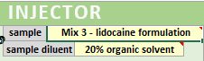
Select the mixture to be analyzed on the “ injector ” module. Choose “Mix 3 - lidocaine formulation”. This mixture contains the constituents of an injectable local anesthetic formulation. It comprises lidocaine (active ingredient), the methylparaben and propylparaben (preservatives), and 2,6-dimethylaniline (degradation product of lidocaine by hydrolysis of the amide function).
This part of the work will be done exclusively on lidocaine.
Adjust the mobile phase to 20 % acetonitrile in isocratic elution mode. The isocratic elution mode and the %ACN must be selected on the “pump” part, while the nature of the organic solvent used (acetonitrile) must be set on the “mobile phase bottles” part.

The reference column will be used, i.e. length 150 mm, diameter 4.6 mm, 5µm particle size.

The theoretical plate height value (H) for lidocaine should be calculated from Equation 5 using the column length (150 mm) and the plates number (N) given in the results table (blue table). The values ​​of H will be calculated in µm.
Perform the virtual experiments at different flow rates, to assess the dependence of the H (HEPT) on the mobile phase flow rate. Prepare a table summarizing the data.

How do the retention times (t_{R}) and the retention factors (k') change when the flow is modified ? Explain this behavior ?
Plot the graph of H (µm) as a function of the flow rate.
Where is the optimum of the curve ? What is your conclusion ?

3.2. Influence of particle size and column length on efficiency

Adjust the mobile phase flow rate on the " pump " part to the optimum found in exercise 3.1.

Change the particle size of the column and use a value of 1.7 µm.

Compare the values ​​of N with those obtained in Exercise 3.1. for a given flow rate with the 5 µm phase. Which column has the greatest efficiency?

Set the particle size of the column again to 5 µm. Change the column length to a value of 50 mm.
Then, carry out the same series of experiments as in exercise 3.1., this time reporting the values ​​of N as a function of the flow rate. Enter the results in a table and make a graph representing N = f (Flow rate).

At the optimum flow rate, compare the value of N to that obtained in exercise 3.1. with the column of 150 mm. Which column is the most efficient? Conclude on the influence of the column length on efficiency (N).

3.3. Influence of the various parameters on the back pressure
Start by clicking on the reset button so that all the values ​​of the software are reset.

Within the system, the pumping of mobile phase through the chromatographic column generates pressure. This pressure, also called back pressure in HPLC, is usually measured upstream of the chromatographic system, at the pumps.
Each HPLC system and each column has a pressure limit that must not be exceeded, otherwise the equipment will be damaged. Changes in the various parameters of the chromatographic analysis (stationary and mobile phase) lead to changes in the back pressure.
The software is able to estimate the back pressure (in bar) for a given analysis by directly reading the value calculated in the "pump" part . This back pressure corresponds to the total pressure in the HPLC system (column and tubes)

Use the software to vary the following parameters and observe their influence on the back pressure:
Column length
 Column particle size
 Mobile phase flow rate
 Mobile phase temperature
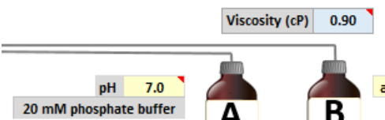
Draw a graph showing the evolution of the backpressure for each of the parameters and describe this evolution in a few words. The software also provide the mobile phase viscosity value expressed in centipoise (cP), which can be a useful data to explain a change of back pressure in the system.

Here is an example of graph (backpressure versus flow rate):

Optimizing a separation in gradient mode
In HPLC, there are 2 elution modes: isocratic and gradient. Isocratic means "constant composition". During an isocratic mode analysis (mode used since the start of this work), a constant mobile phase composition is used.
It is also possible to carry out separations in which the mobile phase composition changes over time. This is referred to as “gradient mode”, where changes in the mobile phase composition are carried out during analysis to elute the compounds. This method of elution is particularly useful when compounds of very different hydrophobicity must be separated.
In isocratic elution, the width of the peaks increases linearly as a function of the retention times. This represents a major disadvantages of isocratic mode: peaks having a late elution become wide. Conversely, the gradient mode tends to reduce the retention of compounds eluting lately and induces a compression effect over the width of the peak. As a result, the peaks are eluted faster and are thinner than in isocratic mode.
4.1. Optimizing impurity profiling method of a pharmaceutical compound
Start by clicking on the reset button so that all the values ​​of the software are reset.

HPLC chromatography is routinely used for the determination of impurities both on the crude active ingredient and on the formulated drug. Impurity profiles are then necessary to demonstrate the ability to detect a large panel of impurities which may also be present within the drug product.

This exercise presents a real-life pharmaceutical analysis typical of the industry. For this purpose, salbutamol has been selected as a model drug. Salbutamol is a β2-adrenergic receptor agonist (short-acting bronchodilator) used for the relief of bronchospasm. It is recommended for the treatment of asthma attacks.
The aim of this exercise will be to find analytical conditions allowing the separation of salbutamol and its various impurities described by the European Pharmacopoeia (B, D, F, G).
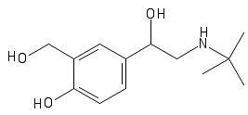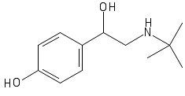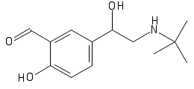
Salbutamol Imp B Imp D
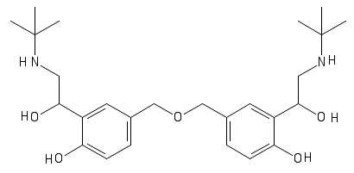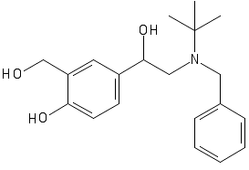
Imp F Imp G
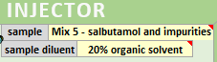
Select the mixture to be analyzed on the “injector” module. Choose “Mix 5 - salbutamol and impurities”. This mixture contains salbutamol and its 4 main pharmacopoeia impurities.
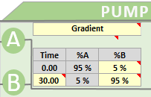

Select gradient mode on the "pump" module. You will then be able to set the gradient time as you wish, as well as the initial and final percentages of acetonitrile in the gradient program.

Now, freely optimize the separation so as to have a baseline separation of all compounds (Rs ≥ 1.5) , while having rapid separation (less than 10 minutes).
The parameters that you can vary are: the elution mode (isocratic or gradient), the mobile phase composition and / or the gradient parameters, the flow rate, the column length (to be chosen between 50 and 250 mm) and the column particle size (to be chosen between 1.7 and 10 µm).
The parameters imposed are: the temperature at 30°C and the column diameter at 4.6 mm. You must also take care not to exceed the maximum system pressure which is 600 bar.
After optimizing your method, make a copy of the obtained chromatogram indicating the analysis conditions.
Try to explain why the impurity F always offers a greater asymmetry compared to the other peaks?
Also explain why the impurity G is systematically more retained than the other ones ?

Once the optimal separation has been obtained for salbutamol and its 4 impurities, you will try different solutions to improve the sensitivity in HPLC-UV, focusing on the impurity D, which is the most critical one of the mixture.

Initially, you will have to optimize the UV wavelength on the module "UV detector", in order to maximize sensitivity while still being on a part of the UV spectrum where the derivative is close to zero in order to have the best possible repeatability. For this, use the UV spectrum of impurity D which can be obtained on the right side of the software.

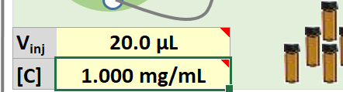
Then, modify the injected volume, in the “ injector ” module to improve the height / area of ​​the peaks. An increase in the injected volume induces an increase in the height / area of ​​the peaks, but also a peak broadening. Make sure to increase the injected volume as much as possible, while maintaining a resolution greater than 1.5.

Then, determine the limit of detection, LOD ( concentration to obtain a S/N = 3 in the blue table) and the limit of quantification, LOQ ( concentration to obtain an S / N = 10 in the blue table) of the impurity D for the developed method. To do this, you can adjust the concentration injected in the "injector" module.
Report the LOD and LOQ obtained for this impurity D in the optimal conditions (express these LOD / LOQ in ppm).

Finally, vary the concentrations between the LOQ and the highest level of impurity D concentration that can be analyzed with this method (as a reminder, a UV detector is linear in a range of absorbance up to a maximum of 1.2 AU).
Report the values of heights and areas of peaks (in the blue table of the software), for 6 concentration levels between LOQ and the highest concentration analyzed.
Then, draw two graphs representing the height and the area of ​​the peak of the impurity D as a function of its concentration (expressed in ppm).
What are we drawing such curves (what is the purpose)?
What can you say about the y-intercept of the curves obtained on these 2 graphs - Explain your observations?
What does the slope of the curve representing the height = f ([C]) represent?
If you have an unknown sample that gives you a height of 5 mAU for the peak of impurity D, which concentration does that correspond to (in ppm)?
Do you think it is better to use the height = f ([C]) or area = f ([C]) curve for an accurate quantitative analysis of the impurity D ? Justify your answer.

